SESSION 3: CHALLENGES OF DLI
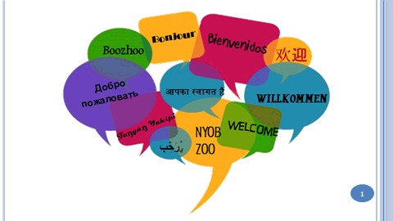 | 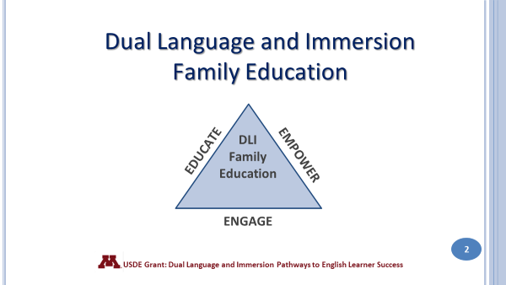
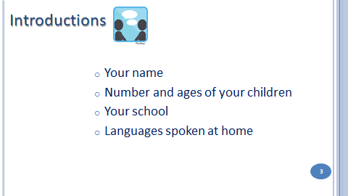 | 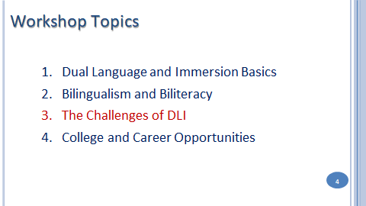
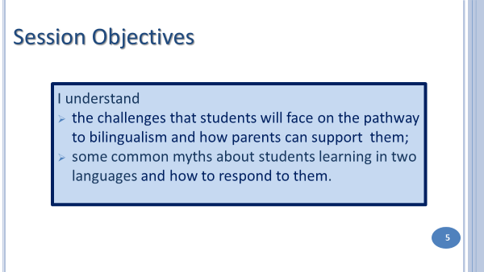
English is the superpower of languages, not only in this country, but around the world. Our Spanish home language students are surrounded by English and since it is the language of peer culture, movies, TV, the Internet, video games, etc., they are motivated to learn and use the language outside of school. Many come to prefer English over their own language. Social pressure to speak English is so great that immigrant parents may notice resistance to using the home language as early as kindergarten. A generation later, however, even if grandparents continue to use the home language, their grandchildren will often respond to them in English. Linguists call this the “three generation pattern.”

English home language students also are challenged by the power of English. Because of the limited amount of exposure they have to a second language, it is much harder for them to achieve proficiency in that language, so they tend to revert back to English whenever they can.

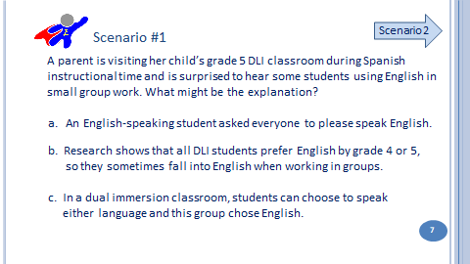 | 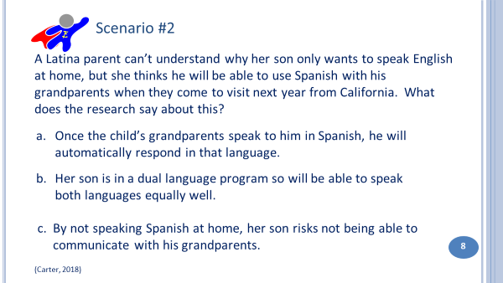
 | 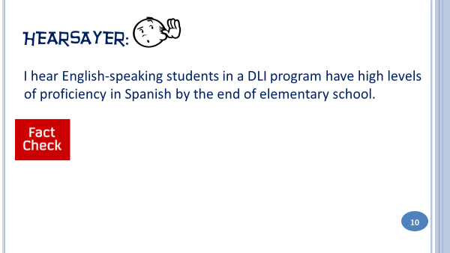
Testing is used in schools to measure student achievement. The Minnesota Comprehensive Assessments (MCA) are the state tests | that help districts measure student progress toward Minnesota’s academic standards. Students take tests in reading and math,beginning in grade 3, and science in grade 5. These tests are a challenge for DLI students who may have received initial literacy instruction in Spanish during the primary grades. Because of the lag in their English reading skills, they may score poorly not only in English reading but in math and science as well. This affects both groups of students. English home language speakers will likely score lower than their third grade peers, though they usually catch up within a year after formal instruction in English language arts begins. Spanish speakers, however, take much longer to develop strong enough English literacy skills to do well on standardized tests. Another consequence of statewide testing is that schools feel pressured to start English earlier than they need to in order to show high test scores on the MCA.
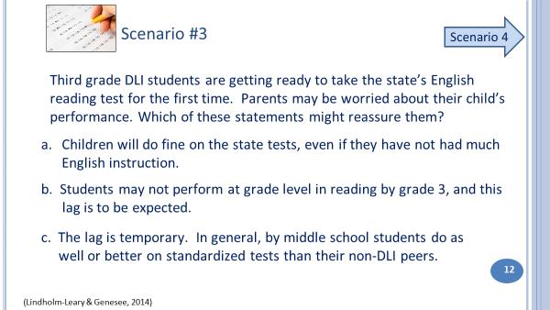 | 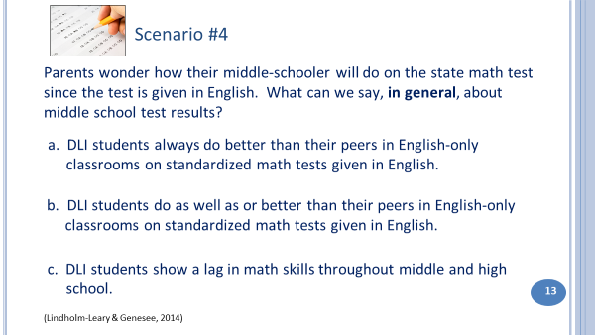  Slide 14: Fact or Myth?
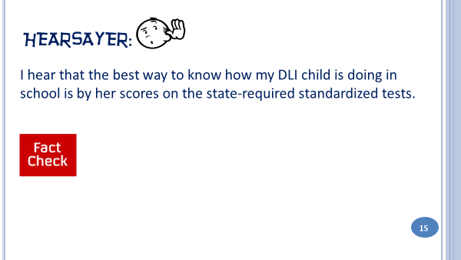 | If you are concerned about your child’ performance, the best way to check on it is to talk with the classroom teacher. It is also important to keep in mind that school learning is not just about academics. Schools are also places where children learn important social skills, cultural understandings, and how to be a good citizen, none of which are assessed on standardized tests.
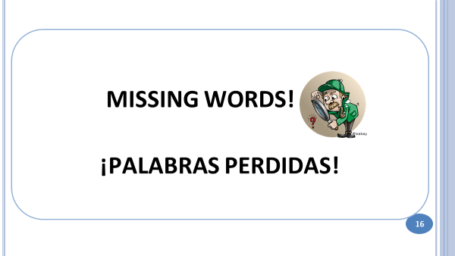
Slides 16-22: Missing Words!
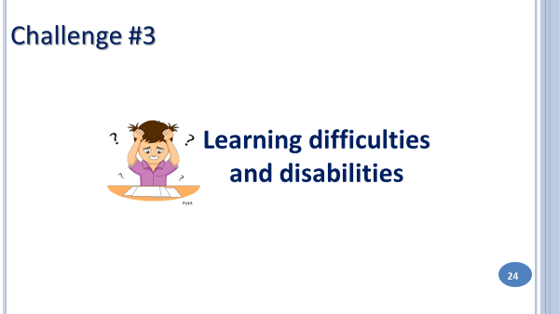 | When students struggle, parents often jump to the conclusion that it is because their child cannot cope with learning two languages at the same time. It is true that for some children, the DLI setting can be more challenging than for others. But you have learned that it takes time to develop language and literacy and that a lag in these skills in the early years of elementary is to be expected. If you or your child’s teacher suspects it is more than that, it is important to discuss your concerns. Other learning specialists at the school may also be part of the discussion.
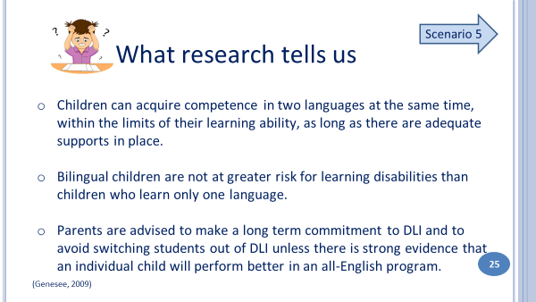 | 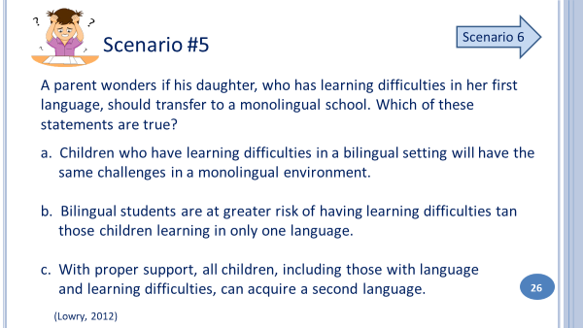
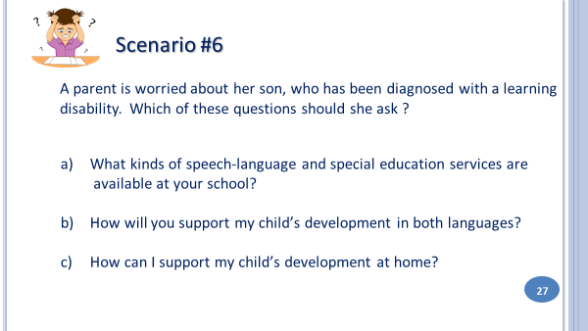  Slide 28: Fact or Myth? | 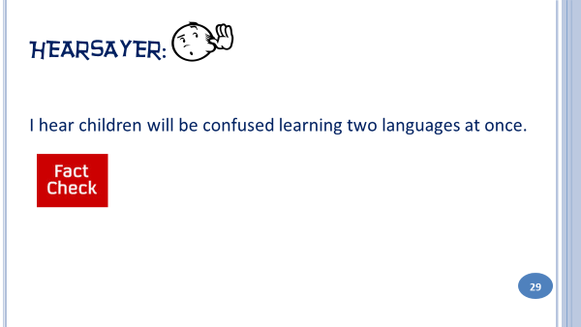
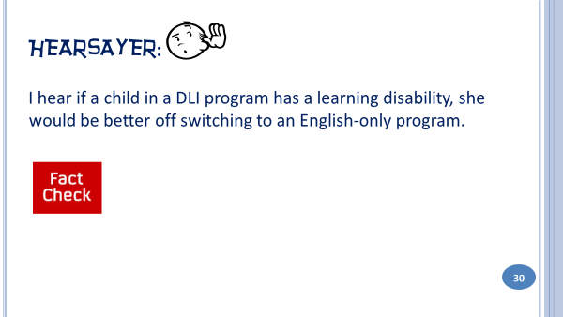 | 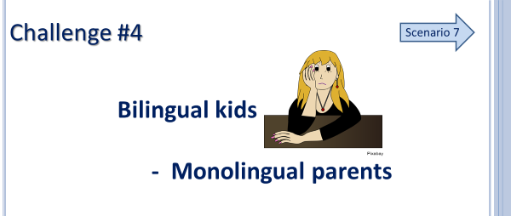  Parents often worry that they will not be able to help their child if they are not bilingual or biliterate themselves. But there are many ways that you can support your child, even if you do not speak both languages of the DLI program.
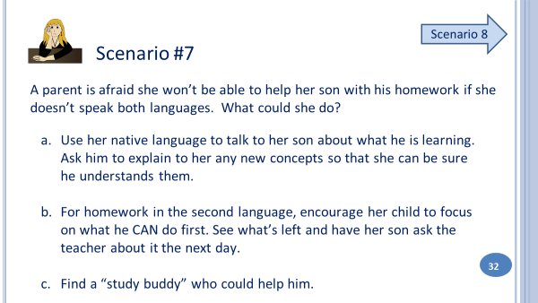 | 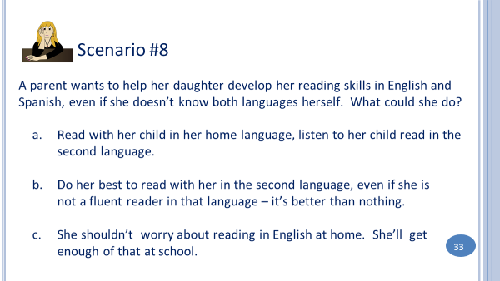  Slide 34: Fact or Myth?
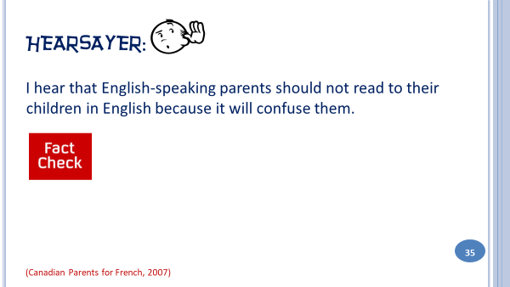 | 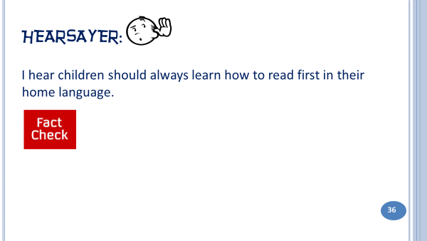  Slide 37: Continued fact check
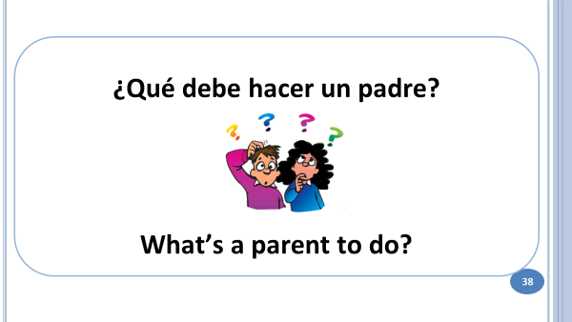  Slides 39 – 42: What’s a parent to do? | Slide 43: Feedback  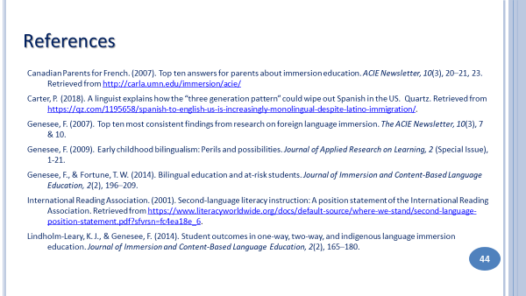
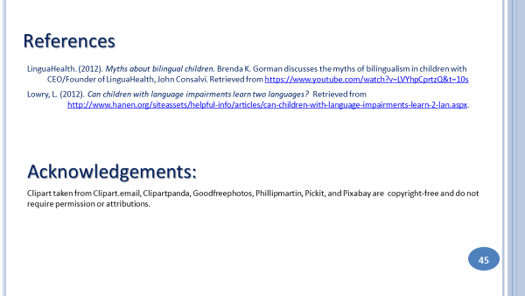

Answers to Discussion Questions
Slide 7: Answer: b.
a. This is possible, but students often fall back into English without even thinking about it.
b. Also, Spanish speakers find it frustrating to speak in their language when other students can’t communicate that well in return.
c. It’s up to the teacher, not the students, to set the language of instruction for each lesson.
Slide 8: Answer: c
a. He may understand his grandparents pretty well and may even be able to speak to them, but over time, he will be able to access less and less his home language.
b. The goal of DLI is to achieve high proficiency levels in both languages, but this takes many years. Even then, one language may still be stronger than the other, and it’s often English. Also, a DLI education is not going to magically turn your child into a fully balanced bilingual!
c. Research shows that immigrants’ children tend to become bilinguals who overwhelmingly prefer English. As a result, the same immigrants’ grandchildren likely speak English only.
Slide 10: Compared to traditional language learners, yes. But because they are surrounded by English, students need extensive added exposure to both social and academic language if they are to become bilingual and biliterate in Spanish. It takes many years – from kindergarten through high school and beyond – to achieve advanced levels of proficiency in a second language. (Genesee, 2007)
Slide 12: Answer: - b and c.
a: Some children – especially those who have had a literacy-rich home environment- may do well on the tests, but this is not the expectation.
Slide 13: Answer: b
Slide 15: Standardized tests are just one measure of a child’s learning. How the child does in the classroom is equally if not more important than her scores on standardized tests.
Slide 26: Answer: Both a and c
Slide 27: Answer: all three!
Slide 29: Children may mix languages from time to time, or they might use words from both languages in the same sentence. This is a normal stage of bilingual development. Speakers will ultimately learn to separate both languages correctly. (Gorman, 2012)
Slide 30: There is no evidence that this is so. Children who have learning disabilities in a bilingual setting will
have the same challenges in a monolingual setting. (Gorman, 2012)
Slide 32: Answer: All 3!
Slide 33: Answer: a
b - When you read aloud you are modeling fluency, expression and pronunciation, so you should read in the language you are most comfortable with.
c) The role of English at home will depend on the program model and will change as students move up in the grades . Your child’s teacher will communicate with you about how to support your child’s biliteracy development.
Slide 35: English-speaking parents should read to their child in English, share their love of books and provide a rich literacy environment in their home. However, they should not attempt to teach their child how to read in English. It's not necessary! They will learn to read in English in school.
Slide 36: This is true for Spanish home language speakers. Such instruction builds on children’s strengths and
connects unfamiliar material to the familiar. Literacy skills developed in the home language can then be applied to learning to read and write in a second language (English). (IRA, 2001)

