SESSION 1: DUAL LANGUAGE AND IMMERSION BASICS
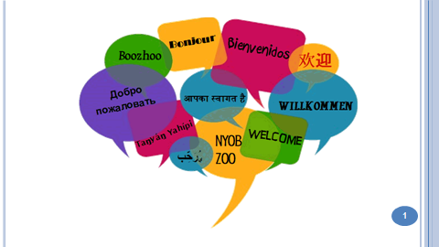 | 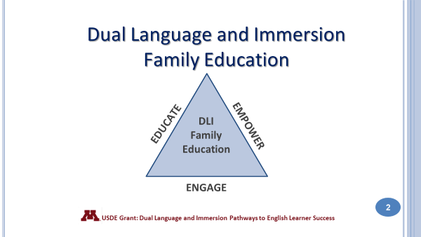
Thank you for joining us this evening. We hope that you will enjoy the learning activities that we have prepared for you. Please do not hesitate to ask questions during the presentation.

The Dual Language and Immersion Family Education program is supported by a United States Department of Education grant from the Office of English Language Acquisition.

We are going to be giving these sessions bilingually rather than separating you into different language groups. Your children are together for instruction and that integration is key to program success. Keep in mind, however, that although we will be doing these sessions bilingually, your children are taught in one language or the other – the teachers don’t translate or use both languages during their instruction.
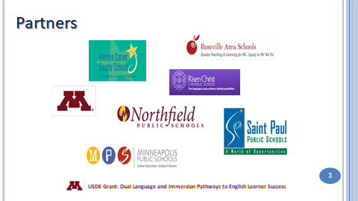  This grant was awarded to the University of Minnesota in partnership with the following districts/programs: Eastern Carver County Schools, Minneapolis Public Schools, Northfield Public Schools, Richfield Public Schools, Risen Christ Catholic School, Roseville Area Schools, and Saint Paul Public Schools. | 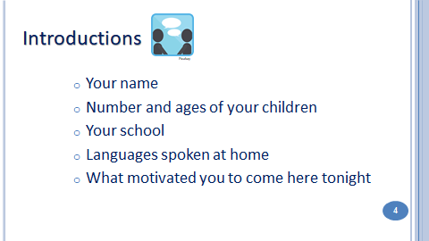
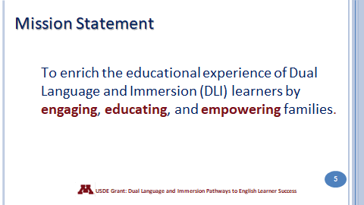 | 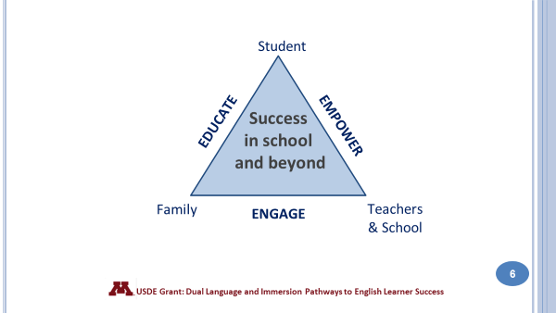
So what does this mean? Point to the 3 points of the triangle to emphasize this partnership.
Students, families, teachers and other school professionals work in partnership to ensure that students achieve success while in school and beyond into the future.
First, it is important for parents and families to be engaged in their children’s education. To be engaged means giving your full attention to something, to be in it – to give it your all. The same expectation holds for teachers and students – the idea is for everyone in this partnership to be committed to the child’s education and to give it their all.
It is also important for parents and families to be educated and informed about the program – to understand what dual language and immersion programs offer children so that you are able to ask questions and offer feedback to teachers and other school professionals.
Finally, it’s critical for families and parents to become empowered. When you’re empowered you feel stronger and more confident, especially when it comes to supporting your child’s education and asserting your child’s educational rights.
When you are engaged and educated, you become more empowered. Those 3 attributes will help lead to your child’s success in school and beyond. You are your child’s strongest advocate and asset!
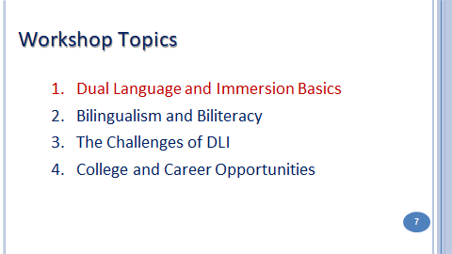 | These are the four topics to be covered in the Family Partnership workshops. We strongly encourage you to attend all four sessions. You will graduate and receive a certificate after completing all four classes.  - What do we mean by Dual Language and Immersion? What are the most important things to know about it?  - What do we mean by “bilingualism” and “biliteracy”? How can you help your child become bilingual and biliterate?  - What are some of the challenges that you and your child might face in a DLI program ? How can you meet those challenges?  - How can bilingualism and biliteracy open doors for your child in the future?
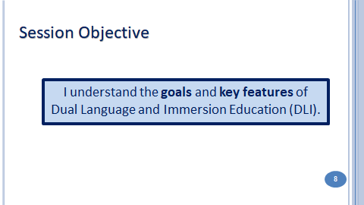 |  | 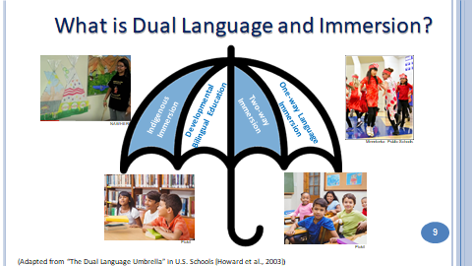
DLI education fosters the idea of additive bilingualism, where students become highly proficient in both English and the partner language.
There are four main program types that fall under the DLI umbrella.
Point to each section of the umbrella as you introduce the four prototypical program types that exist in the US. IMPORTANT: Some programs in MN might not correspond exactly to the four described here.
- Indigenous/Heritage language immersion: These programs are designed to revitalize endangered indigenous – or native - cultures and languages. They typically enroll students of indigenous heritage. In Minnesota we have Ojibwe and Dakota language immersion programs.
- Developmental Bilingual Programs: These bilingual programs serve language learners with similar language and cultural backgrounds – for example, a group of students who speak Spanish at home. Learners have the opportunity to maintain and improve their home language as they learn English. In Minnesota the developmental programs are all in Spanish.
- One-Way World Language Immersion: This program is designed for learners whose home language is English. In Minnesota there are one-way programs in Spanish, French, German, Mandarin and Korean.
- And finally, the program that is represented here tonight is the Two-Way Immersion program. It intentionally brings together children from two language groups – English home language and those who speak the partner language (Spanish) at home. In MN we have two-way programs in Spanish and Hmong.

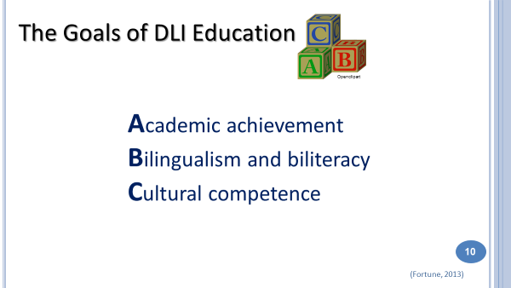 | All four of these program types share the same 3 goals. Think of the ABCs of Dual Language and Immersion:  - Academic achievement has to do with how well students do in school.  - Bilingualism means speaking two languages to a high degree. Biliteracy means reading and writing in two languages.  - Cultural competence is about understanding how culture (our own and other cultures) affects the way we think and act.
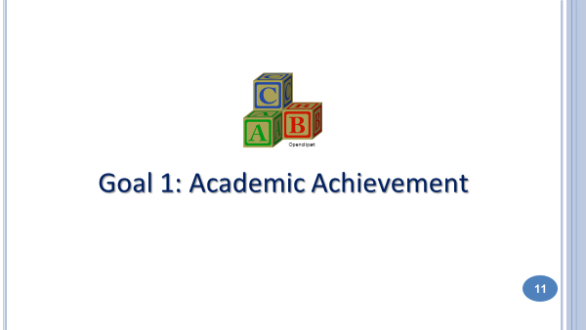 | 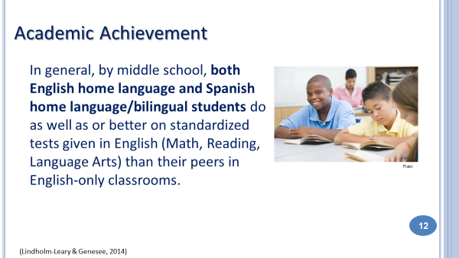
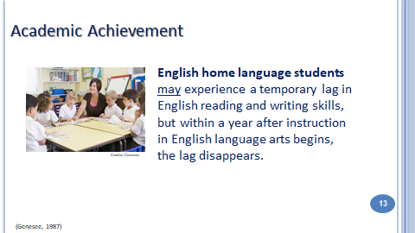 | 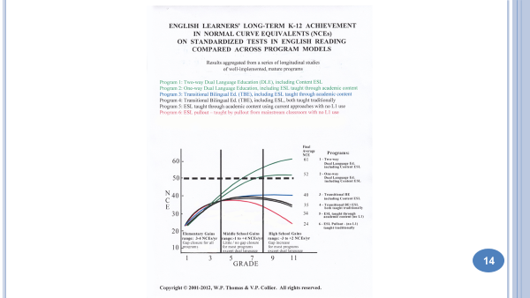
14. This graph shows how English learners achieve in English reading in a variety of program models. It represents longitudinal research involving over 15,000 students in different programs and languages across several US states (but not including MN). Longitudinal research means that we’re looking at the same students over time. Let’s look at a larger version of the graphic to better interpret it.
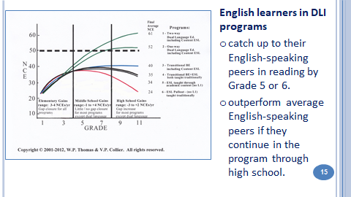 | 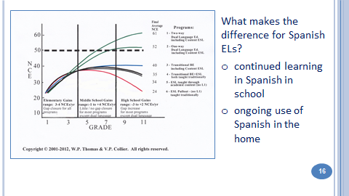
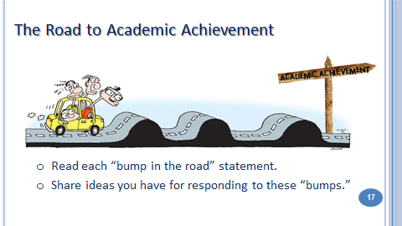  The road to bilingualism is a bumpy one! Tonight, you will learn how to deal with those bumps with your child. The first two bumps are about Academic Achievement. | 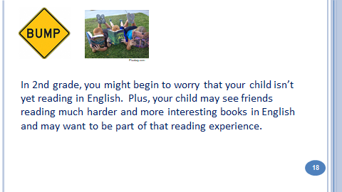
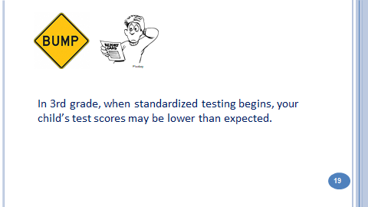 | 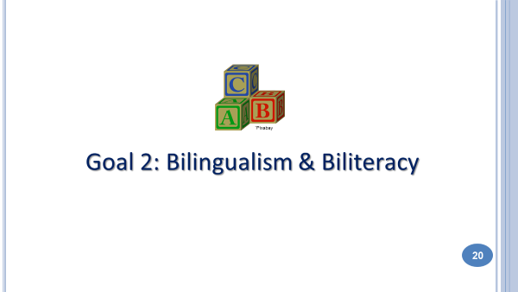  The second goal of DLI is Bilingualism and Biliteracy. Because there is so much information to share about this goal, we will dedicate the entire next session to it. Be sure to come back for this important presentation.
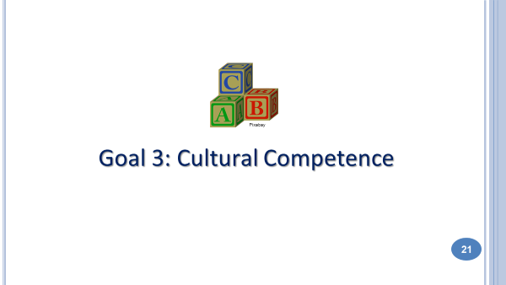 | 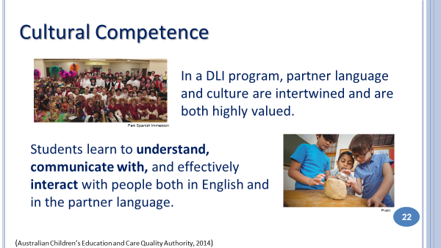
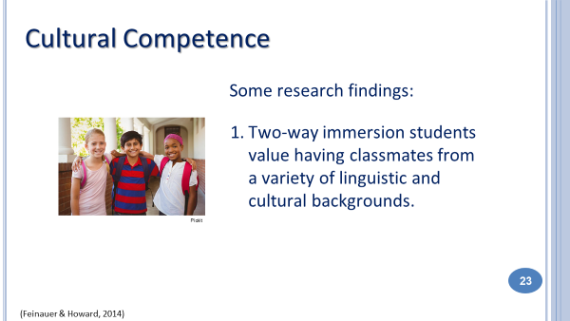 | 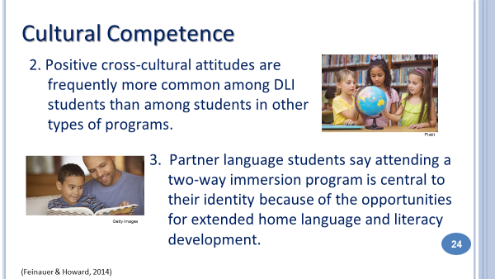
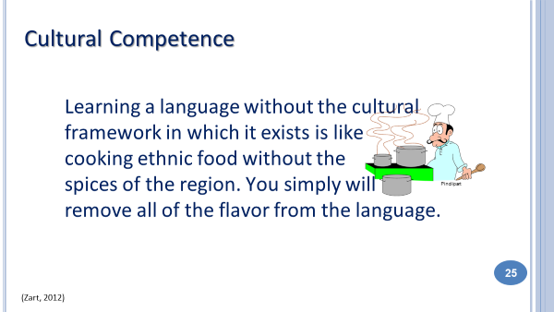 | 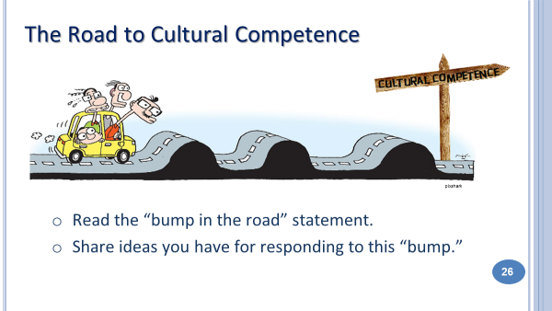
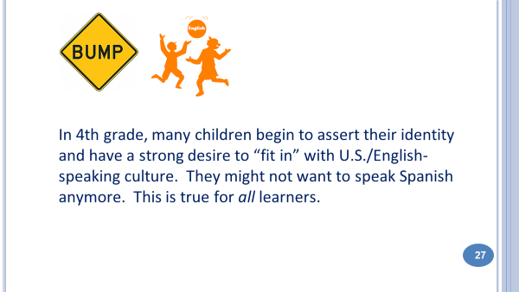  28: Take a Break 29: Bingo | 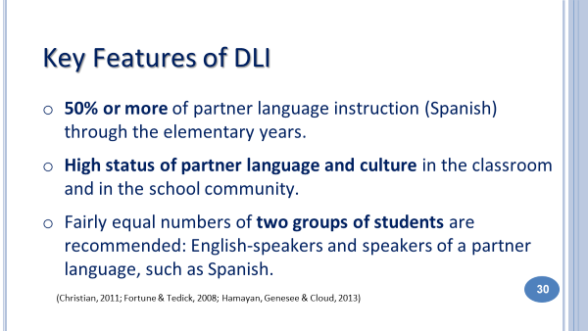

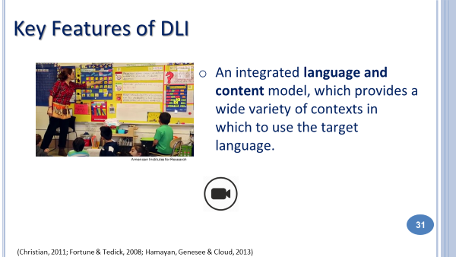 | In the photo you see an example of a kindergarten calendar routine in Spanish. Besides learning math concepts through this daily routine, DLI students learn the foundations of the partner languages: colors, numbers, days of the week, weather expressions and even clothing.  In the video you see students learning Spanish in a wide variety of content areas, from preK to 5th grade. Although this is a one-way program, it gives you a good picture of what it’s like for children to learn math, science, social studies and more in Spanish.
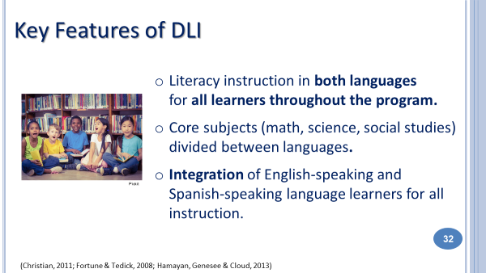 | 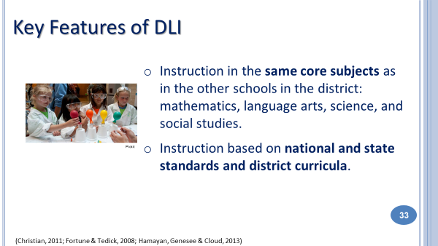
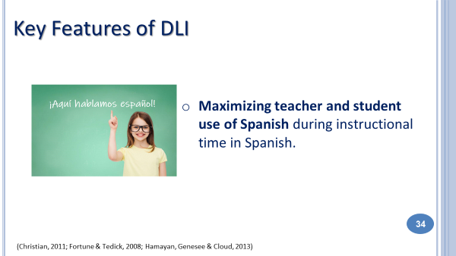  Research on how we learn second languages shows that we have to use the language consistently in order to learn it. We have to prioritize, privilege and protect Spanish in these programs. Students WILL learn English – it’s Spanish that is more challenging for us to develop in these programs – even for Spanish home language students. | 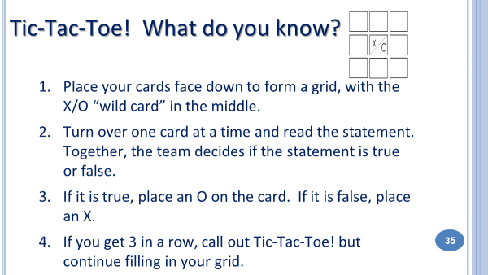  36-37: Tic-Tac-Toe
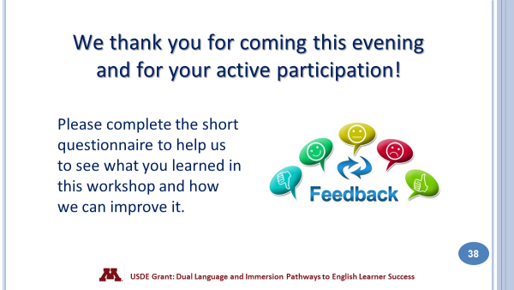 | 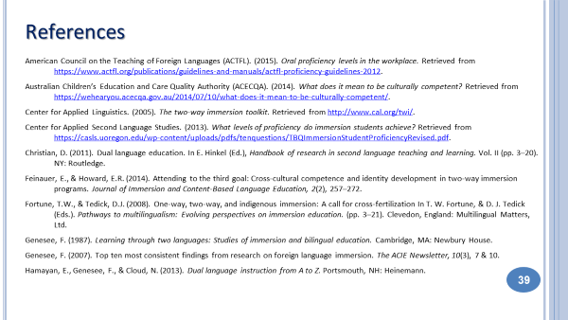
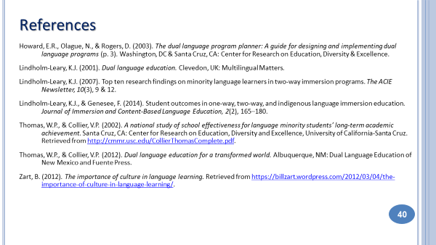 | 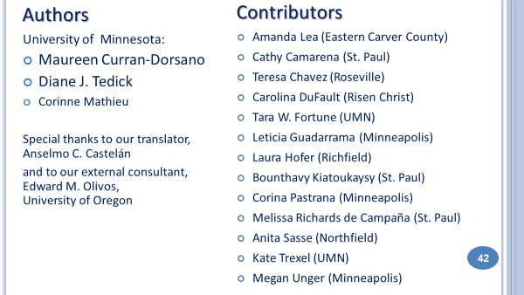

ANSWERS
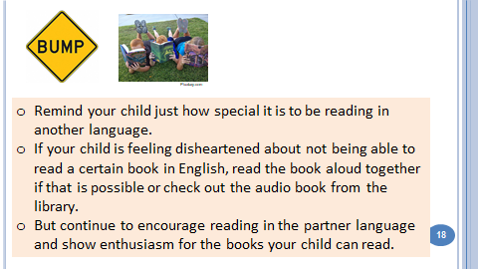 | 