III: KEV NYUAJ LOS NTAWM KEV KAWM OB HOM LUS
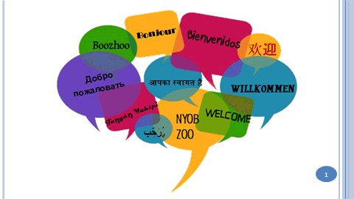 | 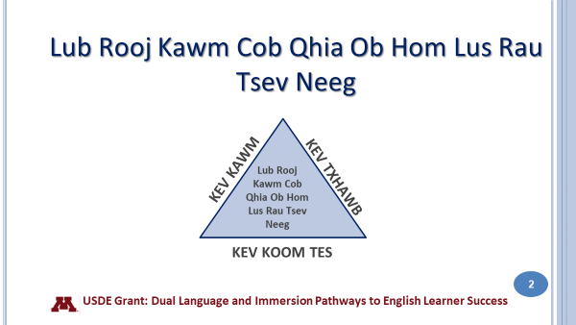
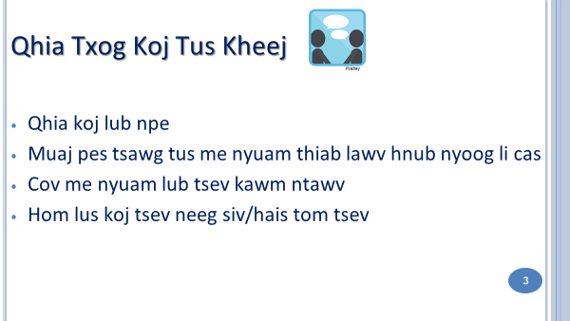 | 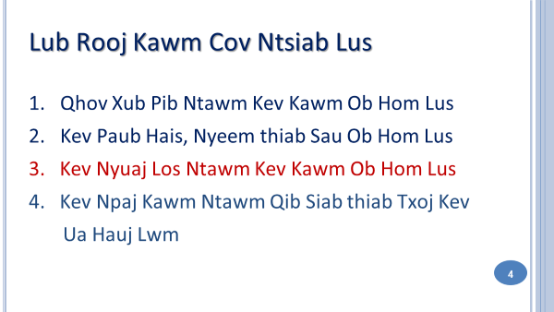
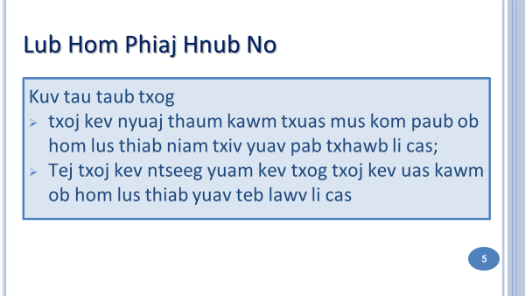 | 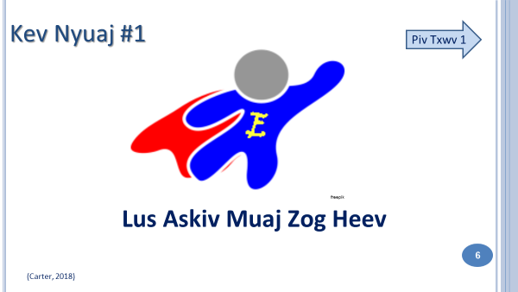
Lus Askiv yog hom lus muaj zog tshaj plaws tsis yog nyob rau lub teb chaw no xwb tiam sis nyob toob lub ntej teb no. Peb cov tub ntxhais Hmoob lub neej nyob nrog lus Askiv txhua txia lub sij hawm ib puag ncig ntawm lawv kev ua si, saib yeej yam kiab, saib thiv vis, internet, video, thiab txhua yam; yog li lawv txog kev kawm lus sib tham pem ces yuav yoog yim thiab yuav ua rau lawv mob siab npos rau. Coob leej coob tus xum siv thiab hais lus Askiv dua siv lawv hom lus. Vim kev yooj kom zoo li cov phooj yooj ywg, hais lus Askiv mas tseem ceeb heev rau cov tub ntxhais thaj nam tawg rog uas nyob lub teb chaw yog li cov niam txiv yuav pom tias lawv cov me nyuam twb pib tsis siv lus Hmoob thaum lawv pib kawm ntawv nyob rau qib Kindergarten lawm.
Nyob rau tiam tom qab mus ces yog cov pog thiab yawg hais lus Hmoob rau cov xeeb txwv ces lawv yuav teb lus Askiv lawm xwb. Qhov no yog kev tshawb los ntawm cov neeg kawm txog haiv neeg cov lus. Qhov no lawv hus ua tiam “ peb tiam neeg tus qauv”

Cov me nyuam uas hais lus Askiv tom vaj tom tsev txoj kev nyuaj tshaj ces yog kev muaj zog los ntawm lus Askiv. Yog hais tias nyob hauv tus me nyuam lub vaj tom tsev es siv lus Askiv xwb ces yuav nyuaj rau tus me nyuam kawm kom paub paub lus Hmoob. Thaum kawg ces tus me nyuam yuav siv lus Askiv rau lub sij hawm twg los tau tag rho.

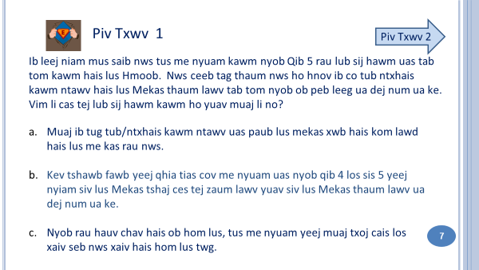 | 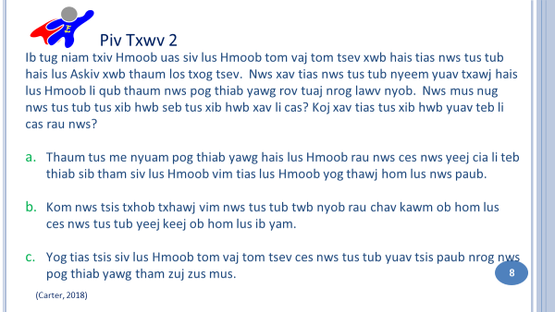
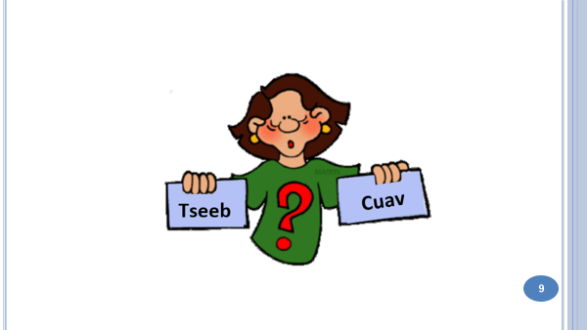 | 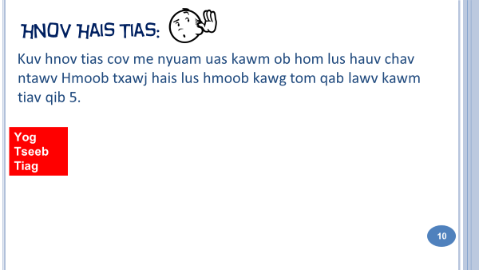
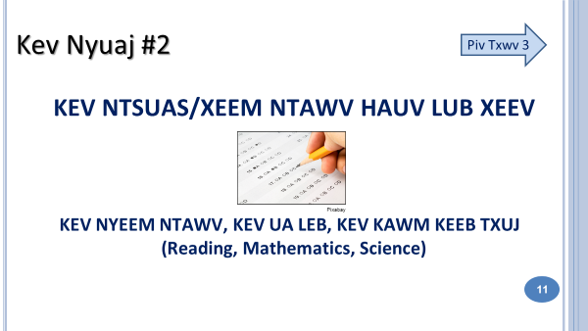 | Kev soj ntsuam yog ib yam uas siv los mus ntsuam xyuas cov me nyuam txoj kev kawm tom tsev kawm ntawv. Tus ntsuam xyuas, Minnesota Comprehensive Assessments (MCA) yog tus xeem los mus soj ntsuam txog cov me nyuam txoj kev kawm hauv lub lav MN. Cov me nyuam raug soj ntsuam rau sab nyeem ntawv, sab ua leb nyob rau qib 3 thiab ntxiv tus xeem keeb txuj thaum nyob qhib 5. Cov kev ntsuam xyuas no yeej nyuaj rau cov me nyuam uas pib kawm ntawv ua lus Hmoob. Vim tias lawv xub kawm ntawv ua lus hmoob, thaum los xeem tus ntsuam xyuas no, lawv yuav xeem tau qis dua cov tub ntxhais uas yog Qib 3 ib yam lawv es kawm ntawv ua lus Askiv xwb. Tiamsis li ib xyoo tom qab uas lawv tau kawm ntawv ua lus Askiv lawm, lawv yuav xeem tau tus ntsuam xyuas no zoo ib yam li tus me nyuam uas kawm lus Askiv thiab. Cov me nyuam uas hais lus Hmoob es raug xeem tus ntsuam xyuas no ua lus Askiv yuav siv sij hawm me ntsis los mus xeem tau tus ntsuam xyuas no. Ib qho uas tsis tshua zoo yog vim tias tsev kawm ntawv paub txog tias tus ntsuam xyuas no yog siv lus Askiv los mus ntsuam xwb ces lawv raug hais kom pib qhia lus Askiv ntxov rau cov me nyuam es cov me nyuam thiaj li xeem tau tus ntsuam xyuas no zoo.
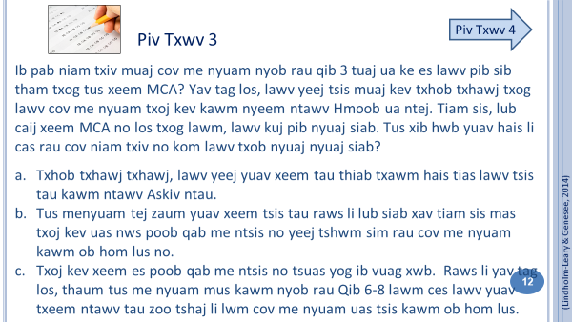 | 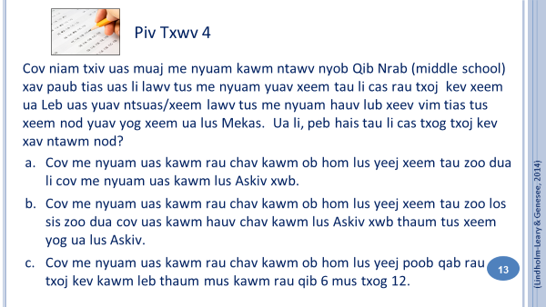  Slide 14: Tseeb - Cuav?
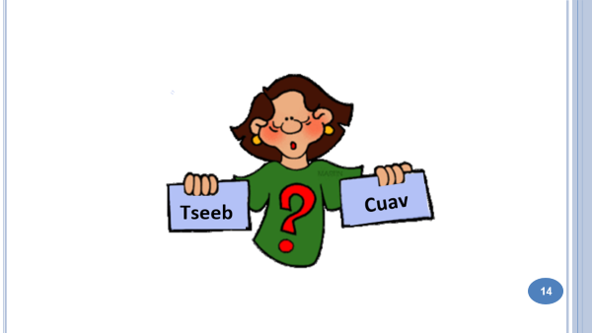 | 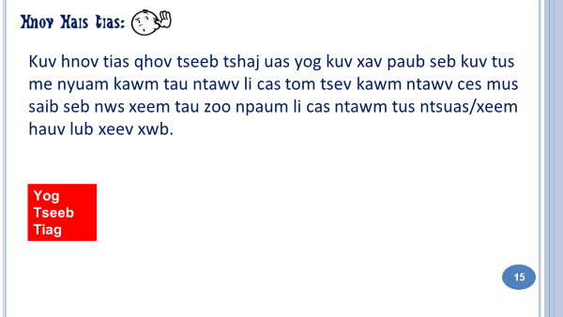

Yog koj muaj kev nyuaj siab txog koj tus me nyuam txoj kev xeem no, qhov zoo tshaj ces yog mus nrog koj tus me nyuam tus xibfwb sib tham. Ib qho tseem ceeb thiab mas yog tias kom koj rov xav txog tias kev kawm tom tsev kawm ntawv tsis tag rau tus xeem xwb. Tsev kawm ntawv yog ib qho chaw uas sawv daws tuaj kawm txog kev paub nrog tib neeg sib txuas lus, kev kawm txuj txog lwm haiv neeg, thiab yogi b qho chaw yus tuaj kawm txog ua ib tug pej xeem zoo. Txhua yam hais no, tsis muaj soj ntsuam kiag hauv tus ntsuam xyuas hauv lub xeev.
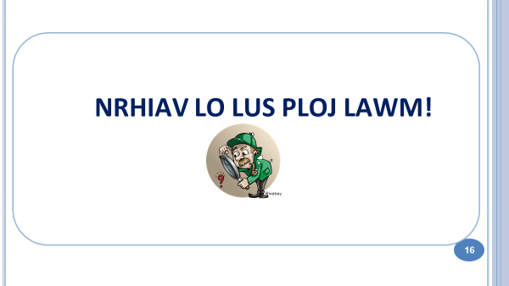  Slides 17-22: Nrhiav lo lus ploj lawm! Slide 23: Mus so lb pliag! | 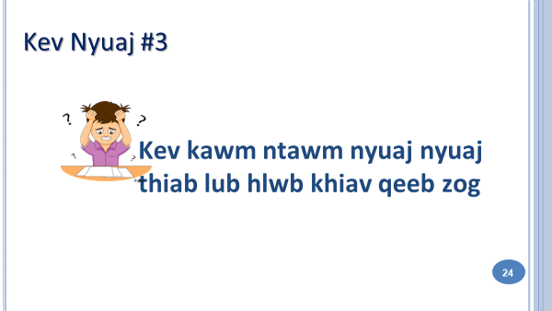
Thaum tus me nyuam kawm ntawv tsis nkag siab zoo, cov niam thiab txiv txoj kev xav ces tsuas hais tias yog vim lawv tus me nyuam tsis paub txog tias yuav siv ob hom lus thooj txhij li cas. Qhov nod yeej muaj tseeb rau ib cov me nyuam, vim tias chav ob hom lub yeej kawm tsis yooj yim rau ib co me nyuam. Tiamsis qhov tseem ceeb, koj yuav tsum nkag siab tias yuav siv sij hawm rau tus me nyuam txoj kev kawm lus thiab kawm nyeem ntawv no. Yog koj los sis koj tus me nyuam pom tias muaj tej yam kev nyuaj siab uas tsis raws li hais los saum nod, txhob ua siab deb mus nrog koj tus xib fwb sib tham txog koj txoj kev txhawj xeeb. Lwm tus qhia txuj uas qhia hauv tsev kawm ntawv los yeej los nrog nej tham los tau tib si.

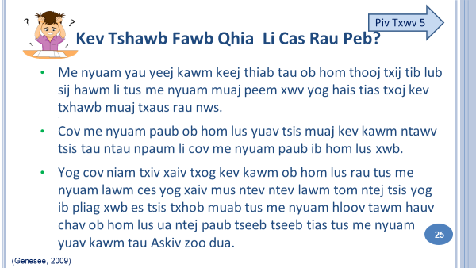 | 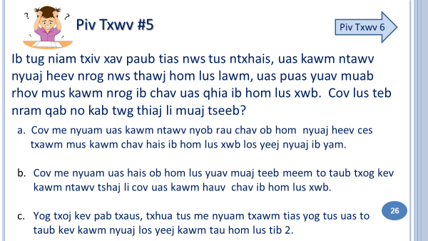
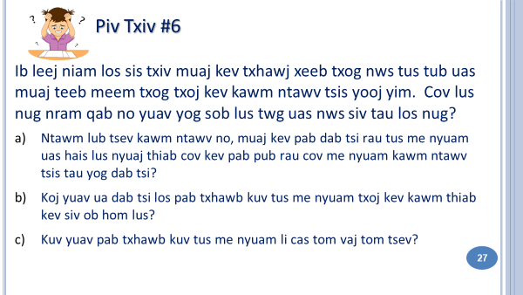 | 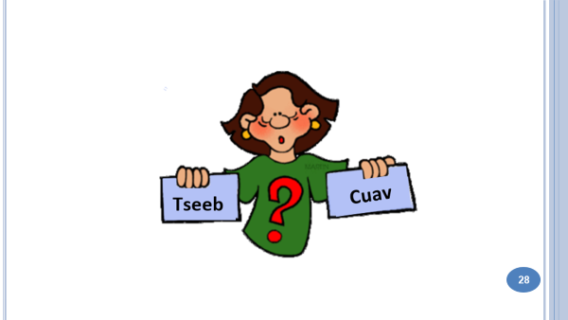
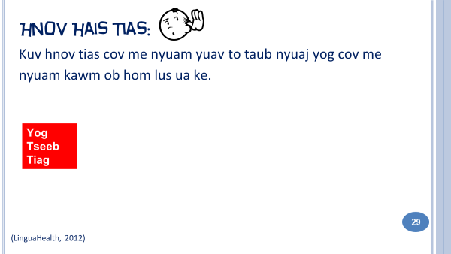 | 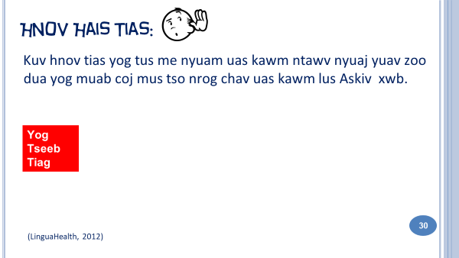
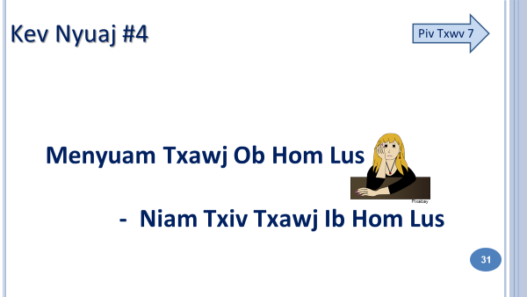  Ib cov niam thiab txiv xav tias lawv pab tsis tau lawv tus me nyuam vim tias lawv hais tsis tau ob hom lus los sis lawv tus kheej tsis yog neeg hais ob hom lus. Tiam sis muaj ntau txoj hauv kev uas koj pab tau koj tus me nyuam, txawm tias koj hais tsis tau ob hom lus. | 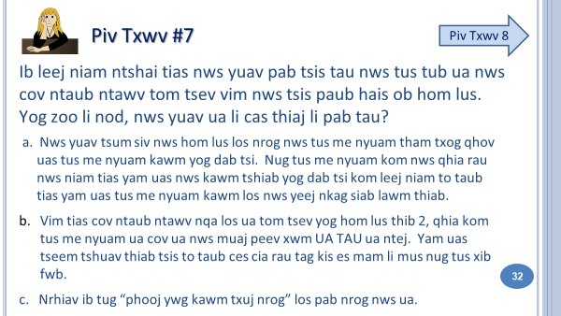

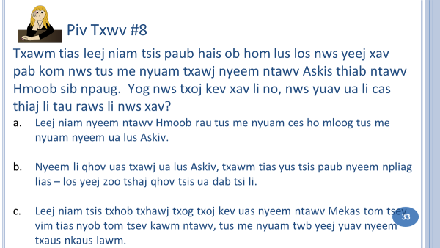 | 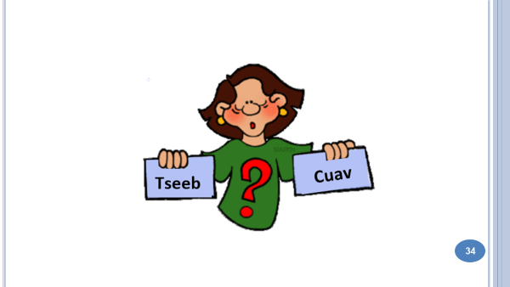
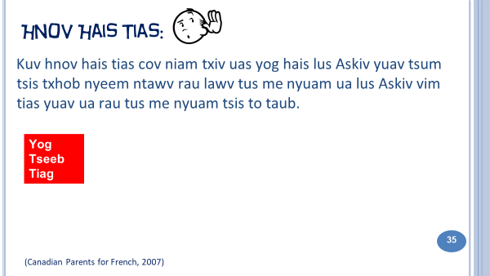 | 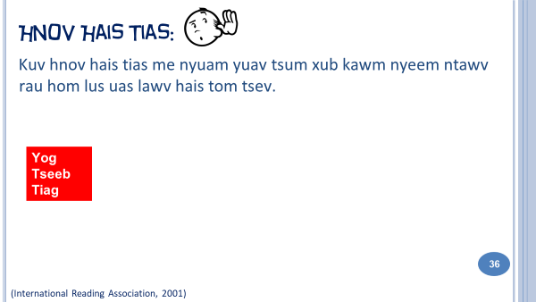  Slide 37: Continued fact check
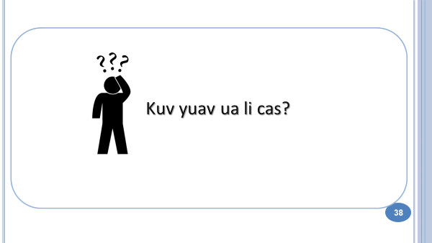  Slides 39 – 42: Kuv yuav ua li cas? | 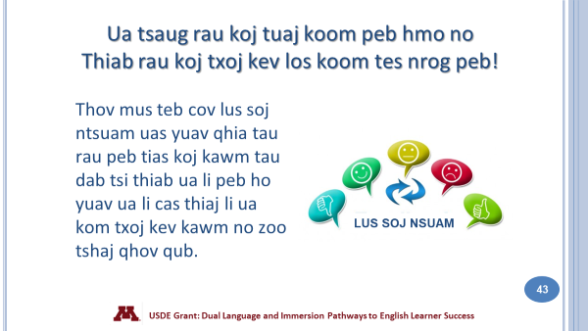
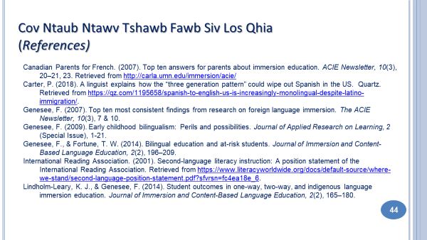 | 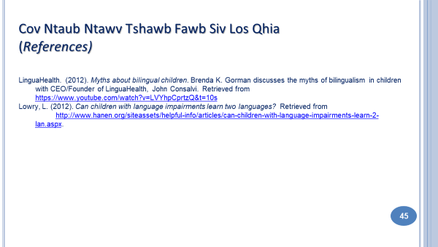

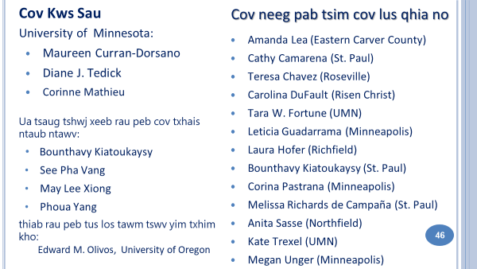

LUS TEB
Slide 7: Qho teb: b
a. Yuav tsis yog li. Cov tub ntxhais uas hauv lus tsev es hais lus Askiv xwb ces tos nco xwb twb yuav cia li siv lus Askiv lawm.
b. Tsis tag li thiab, cov tub ntxhais uas hais lus Hmoob xwb los tseem yuav muaj teeb meem qee rau tom vaj tom tsev thaum cov paub lus Askiv xwb tsis txhawj nrog lawv siv tham siv lus Hmoob.
c. Ib yam tseem ceeb txog ntawm kev kawm ob hom lus ces yog kom cais ob hom lus kom meej meej. Qhov no ces poob mus rau ntawm tus xib hwb, tsis yog cov tub ntxhais kawm ntawv, tias yam lus twg yog yam kawm thiab siv rau lub sij hawm twg.
Slide 8: Qho teb: c
a. Nws yuav tau taub nws pob thiab yawg zoo thiab nws yuav paub hais nrog nkawd sib tham me ntsi tiam sis ntej mus ces nws yuav tsis paub nws hom lus zuj zus mus lawm
b. Lub hom phiaj ntawm kev kawm ob hom lus ces yog kom paub zoo zoo thiab meej meej ob hom tib yam nkaus. Qhov no yuav siv ciaj nyoog ntev thiab ntau lub xyoo. Txawm tias thaum pib es yuav keej thiab paub ib hom lus duas, xws li qhov ntau ces yog lus Askiv. Tsis tag li, mus kawm nyob rau ob hom lus tsis yog hais tias cia li uas rau koj tus me nyuam paub thiab txawj ob hom lus.
c. Kev tshawb fawb pom tau tias cov me nyuam thaj nam tawg rog uas paub ob hom lus lawm los lawv tseem xum hais lus Askiv. Thaum kawg, cov me nyuam thaj nam tawg rog no cov xeeb txhwv ces paub hais lus Askiv lawm xwb.
Slide 10: Yog muab piv rau cov uas yeej ib txwm kawm hais ob hom yus ces yeej, muaj tseeb. Tiam sis vim tias lawv nyob nrog cov me nyuam uas hais lus Askiv, cov tub ntxhais kawm ntawv no yuav tsum muaj ntau yam kev kawm txuj los pab txhawb txoj kev hais lus thiab kev kawm ntawv yog yus xav kom tus me nyuam no nws txawj hais thiab sau lus Hmoob kom tag nws lub peev xwm. Yuav tsum yog ntau xyoo - pib qib kindergarten txog rau qib 12 thiab dhau – kom tus me nyuam no nws thiaj li txawj
siv thiab hais ob hom lus pliag lias. (Genesee, 2007)
Slide 12: Qho teb: b & c
a. Ib co tub ntxhais uas hais lus Askiv xwb tom vaj tom tsev yuav xeem tau rau lawv tus MCA. Qhov no yog ib yam uas cov niam txiv muaj tus me nyuam nyob rau chav kawm ob hom lus txhob rawm txawj txog yog tus me nyuam xeem tsis tau.
Slide 13: Qho teb: b
Slide 15: Kev ntsuas/xeem hauv lub xeev tsuas yog ib hom uas qhia txog tus me nyuam txoj kev kawm xwb. Yog xav paub tseeb tias tus me nyuam kawm tau li cas ces yuav tsum paub tias uas li tus me nyuam kawm tau los tsis tau hauv nws chav kawm thiab.
Slide 26: Qho teb: a & c
Slide 27: Qho teb: a, b, c
Slide 29: Tej zaum cov me nyuam yuav siv lus yuam kev tej lub sij hawm, los sis lawd yuav siv ob hom lus los hais ib kab lus xwb. Qhov uas nws ua li no yeej tsis yuam kev tiam sis mas yog ib qho uas txhua tus me nyuam kawm ob hom lus yuav tau taug mus. Tsis ntev xwb ces nws txawj muab cov lus no cais thiab hais kom raws li nws hom lus thiab hais kom meej meej lawm.
Slide 30: Tsis muaj ib qho kev tshawb fawb uas qhia tias qhov nod muaj tseeb. Tus me nyuam uas kawm ntawv qeeb zog, txawm tias yuav nyob hauv chav kawm ob hom lus los yeej nyuaj ib yam li nyob hauv chav uas kawm ib hom lus.
Slide 32: Qho teb: a, b, c
Slide 33: Answer: a
b. When you read aloud you are modeling fluency, expression and pronunciation, so you should read in the language you are most comfortable with.
c. The role of English at home will depend on the program model and will change as students move up in the grades . Your child’s teacher will communicate with you about how to support your child’s biliteracy development.
Slide 35: Cov niam thiab txiv uas txawj hais lus Askiv xwb yuav tsum nyeem rau lawv tus me nyuam ua lus Askiv, npaj tej ntaub ntawv thiab kho kom yus chav tsev uas yus tseg ua chav nyeem ntawv muaj txhij muaj txhua tej me ntaub ntawv rau tus me nyuam pom.
Slide 36: Qhov nod muaj tseeb rau tus me nyuam uas hais lus Hmoob tom tsev.
- Qhov kev kawm li nod yuav pab tau rau tus me nyuam thaum nws mus nyeem tej ntaub ntawv uas nws tsis tau paub thiab pom dua.
- Qhov kev xyaum nyeem ntawv tom vaj tom tsev no yuav pab tau rau tus me nyuam thaum nws mus kawm nws hom lus thib ob (Askiv).
Slide 37: Tus me nyuam uas pib hais lus Askiv, pib nyeem ntawv rau hom lus thib ob los tau.
- Tus me nyuam uas hais lus Askiv xwb yeej caum cuag cov me nyuam nws lub hnub nyoog txawm tias nws txoj kev kawm muab ncua cia. (Genesee, 2007)
- Vim lus Askiv yog hom lus sawv daws siv. Tus me nyuam uas hais lus Askiv yeej muaj ntau yam kev pab kom nws txawj nyeem ntawv rau lub sij hawm uas ua ntej, thaum nws kawm, thiab tom qab nws kawm ntawv.

